- Codeforces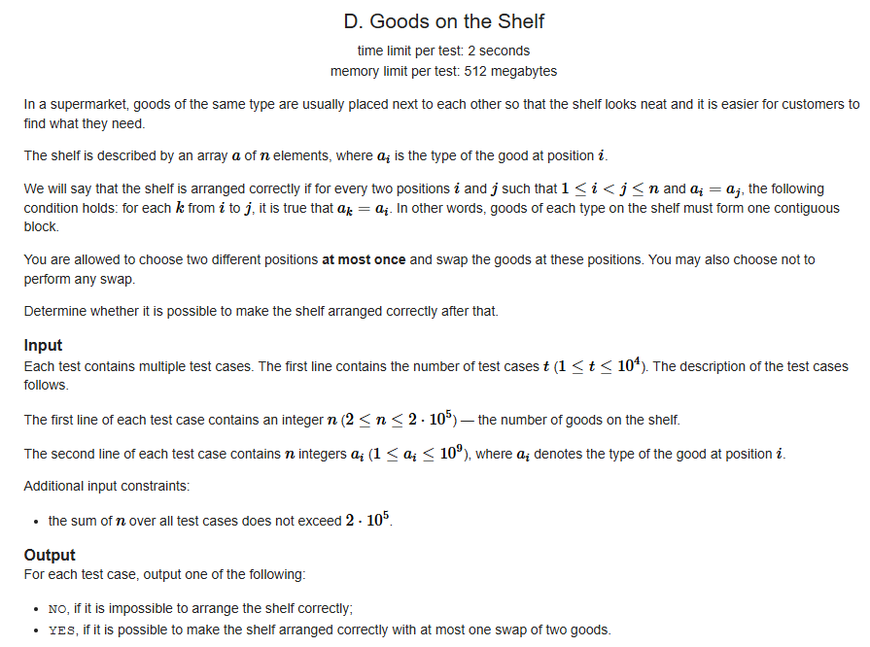

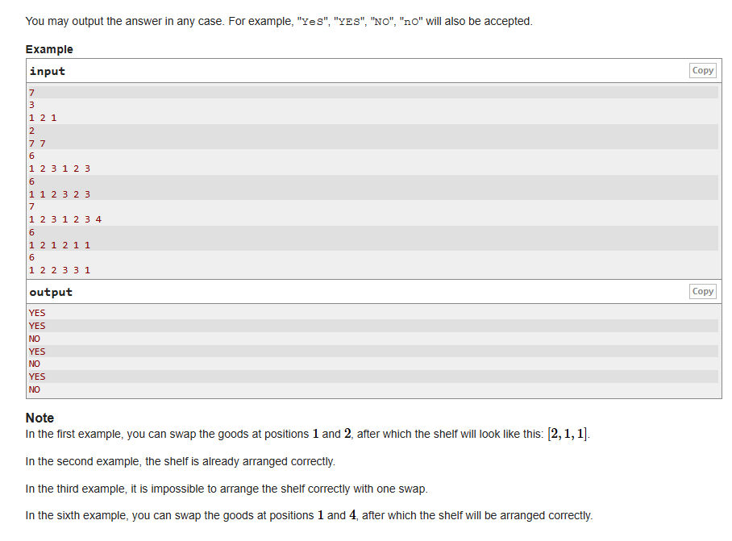
- Cognizant GenC
Lucky number
Problem Statement – Chaman planned to choose a four digit lucky number for his car. His lucky numbers are 3,5 and 7. Help him find the number, whose sum is divisible by 3 or 5 or 7. Provide a valid car number, Fails to provide a valid input then display that number is not a valid car number.
Note : The input other than 4 digit positive number[includes negative and 0] is considered as invalid.
Refer the samples, to read and display the data.
Sample Input 1:
- Enter the car no:1234
Sample Output 1:
- Lucky Number
Sample Input 2:
- Enter the car no:1214
Sample Output 2:
- Sorry its not my lucky number
Sample Input 3:
- Enter the car no:14
Sample Output 3:
- 14 is not a valid car number
- Gofrugal
Decimal to binary
Write a C program to convert a decimal number to binary and print the count of 1's in it. If 1's are not present in binary number, then print invalid input.

